

Inverted Pendulum PID Demonstrator

Project Development Plan (PDP)

Matt Handley, Joseph Sedutto, Austin Cardosi, Kathryn Swineford

Southern New Hampshire University

# 

# Roles

| Team Member | Primary Role | Secondary Role |
| --- | --- | --- |
| Matt Handley | CAD | Calculations |
| Joe Sedutto | Electrical | Machining |
| Kat Swineford | Documentation | Assembly |
| Austin Cardosi | Coding | File Organization |

Table 1.1.1

# 

# Abstract

A PID loop (Proportional, Integral, Derivative) loop is a very common error-reducing algorithm in our modern world. It can be implemented in many different ways, and controls everything from the heating cycle of your toaster, to the cruise control in your car.

The PID loop seeks to reduce the “error” in a system, that error may be the speed you want to go, the target temperature of your toast or the upright position of a pendulum. Because PID is used so extensively, and is somewhat difficult to grasp from a purely numeric perspective, a PID demonstrator is a tool that allows users to interact with and gain a deeper understanding of the underlying control mechanisms.

This PID demonstrator tackles this problem, it uses robust but minimalist construction to create a high quality and easy to maintain demonstrator, users interact with its front panel to tune and de-tune a system managed by PID, a classic inverted pendulum which is a feat many can relate to, balancing a baseball bat on their finger. Its high moment of inertia allows the pendulum to swing and waver when untuned, yet hold perfectly still when tuned correctly.

## 

# Table of Contents

**Roles** **2**

**Abstract** **3**

**Table of Contents** **4**

**Table of Figures** **5**

**Table of Tables** **5**

**The System Description** **7**

Problem Statement 7

Design Research 7

Rotary Inverted Pendulum 7

Reaction Wheel Inverted Pendulum 8

Technical Challenges 8

Customers/markets/economics/applications 9

Concept of Operations **9**

Statements 9

**System Requirements (Top Level)** **12**

Functional Requirements: (what it does) 12

Performance Requirements: (how well it does) 13

Physical Requirements: (sizes, weight) 14

Environmental and Safety Requirements: 14

Engineering Standards: 15

**Risk Assessments** **15**

Risk Assessment 15

**Design Concepts** **17**

Sketches 17

System Composition Block Diagram 19

Flow Chart of Operations 20

Software Flow Chart 21

Health and Safety Design Features: 22

Used Engineering Standards: 22

**Task Plan** **23**

**Budget/BOM** **24**

**References** **25**

**Appendixes:** **26**

Appendix A: Calculations / Model 26

Appendix B: LibreOffice Schedule 27

# Table of Figures

Figure 1.2.1 Rotary Inverted Pendulum……………………………………………………………. 6

Figure 1.2.2 Reaction Wheel Inverted Pendulum…………………………………………………. 7

Figure 5.1.1 Blender Scale Model………………………………………………………………….16

Figure 5.1.2 Blender Full Model…………………………………………………………………… 16

Figure 5.1.3 Carriage Drawing…………………………………………………………………….. 16

Figure 5.1.4 Blender Motor Close-Up Model……………………………………………………... 16

Figure 5.1.5 Belt Tensioning Cam Drawing………………………………………………………. 17

Figure 5.1.6 Early Design Sketch………………………………………………………………….. 17

Figure 6.1.1 System Composition Block Diagram……………………………………………….. 17

Figure 6.2.1 Flow Chart of Operations……………………………………………………………. 18

Figure 6.3.1 Software Flowchart…………………………………………………………………… 18

Figure 7.1.1 Task Plan……………………………………………………………………………… 23

Figure 8.1.1 Bill of Materials……………………………………………………………………….. 24

Figure 9.1.1 Calculations/Model…………………………………………………………………… 26

# Table of Tables

Table 1.1.1 Team Roles………………………………………………………………………………. 2

Table 3.1.1 Functional Requirements……………………………………………………………... 12

Table 3.2.1 Performance Requirements………………………………………………………….. 12

Table 3.3.1 Physical Requirements……………………………………………………………….. 13

Table 3.4.1 Environmental Requirements………………………………………………………… 14

Table 3.5.1 Engineering Standards………………………………………………………………... 14

Table 4.1.1 Risk Assessment……………………………………………………………………….15

# 

# The System Description

## Problem Statement

The goal is to make a PID Demonstrator that is intuitive for all age groups to demonstrate how to use a PID loop and what each individual variable does to effect a vertical standing pendulum.

## Design Research

#### Rotary Inverted Pendulum

The rotary inverted pendulum spins about a fixed central axis that at the end of the attached fixed point has the pendulum. The combination of motor and sensors allow the pendulum to stand itself upright. Based on the pendulum's angle the motor can accelerate in both directions to counterbalance the falling rod. The example below according to the author cost from 200 to 500 dollars depending on the parts and modifications.

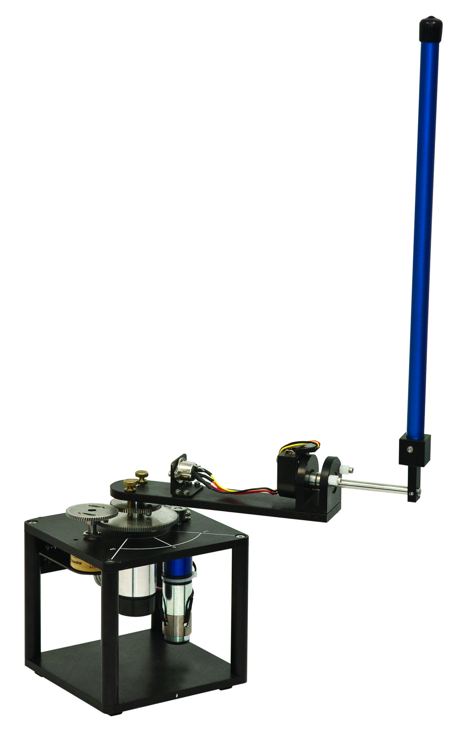(Figure: 1.2.1)

#### Reaction Wheel Inverted Pendulum

The Reaction Wheel inverted pendulum functions off torque by a spinning wheel at the top of the pendulum. The torque and counter-torque used to move the pendulum left or right can allow for the pendulum to have the ability to stand vertically when the PID loop is corrected. This specific example was made with a variety of lego parts and the builder later in the video demonstrates that his loop works with a variety of weights and modifications.

(Figure: 1.2.2)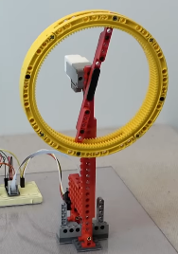

#### Technical Challenges

Challenges that will face the system we are trying to make tuning the pendulum to stay vertical as PID loops can be testy to get right. A potential solution for this is to spend more time perfecting the loop after construction. Another problem that might occur will be to get the pendulum to swing up automatically without any outside assistance. A potential solution for this is to find examples of this kind of pendulum and see how to possibly code a start up sequence. Last problem that might occur is troubleshooting the sensors to ensure accurate and precise readings for demonstrating the graphs of the PID loop. This can be mitigated by testing the sensors prior to mounting them to the system.

## Customers/markets/economics/applications

Demonstrates control systems using a PID loop. Allows users to vary the control loop constants to change the behavior of the pendulum. Educational application for academia and industry.

# Concept of Operations

## Statements

**Stakeholders:** Southern New Hampshire University, Professor Carlstrom, Professor Husson, Professor Guo, educators and academics, industrial training, producers of parts and service.

**Users:** Pendulum team, educators and academia, industrial and software training, and producers of parts and service.

**System Description:** A PID system is a general method for a computer or intelligent system to reduce the error or deviation in a system. Examples include the thermostat in a stove, the cruise control in a car or the gain control on a phone microphone.

This system aims to help display the fundamentals of a PID system in the form of a machine dedicated to allowing the operator to experiment with the tuning and functions behind the algorithm.

It will be constructed from steel and wood, powered by a single motor and a small processor and power supply, portable but robust enough to be installed in semi-permanent use. Weighing between 30 and 50lb, with a tft screen. The system will use a demo PID loop to balance an inverted pendulum and allow user input to control the rates and response of the loop

**Operational Environment:** This demonstrator will be in a high traffic environment, that is possibly dusty. It will be located indoors, and will be powered 24/7.

**Support Environment:** This demonstrator will be made from as many COTS (Common Off The Shelf) parts as possible to ensure simple replacement. The environment the unit is in will affect many parts of this demonstrator

• Wearing components (belts, sliders)

Mitigation all wearable parts will be accessible and removable without major disassembly.

• Constant touching and interaction

Mitigation the demonstrator will be built from sturdy and easy to clean components.

• Constant uptime

Mitigation low power/sleep mode can prolong the life of electronics when not in use

Anything requiring major disassembly, prolonged repair or specialty parts will be built robust and within manufacturer spec with documentation alongside. All systems either self calibrating or not requiring calibration. The system will be designed with long life serviceability in mind.

**Operating Modes:**

• Off mode: the state in which the system is powered down and or unplugged.

• Idle mode: a power saving mode in which fans are turned off; the TFT screen is turned off; and the motor controller, CPU, and power supply will be swapped to their internal lower power consumption mode.

• Spin-up mode: a custom control procedure that self initializes (swing the pendulum up into a ready state using harmonic oscillation.

• Demo PID mode: a built-in PID procedure with lock Kp, Ki, and Kd values to demonstrate how the inverse pendulum is properly balanced.

• User PID mode: a control structure in which the user can manipulate the Kp, Ki, and Kd constants to witness the effects of their changes on the stability of the pendulum.

**Use:** This system will provide an excellent robust teaching tool for its users to grasp and deeply understand the function of a PID loop, which is an essential software and hardware algorithm for many industries.

**Risks:**

• Pinch Points and swinging pendulum

• Failure during demonstrations

• Damaged to the unit from normal use

• Short circuits and electrical malfunctions

• Heat accumulation

**Impact Consideration:** There are some considerations to think about with the implementation of this system:

• Being a hazard and risking misuse.

• Requiring physical space, either for storage or use.

• Producing a significant amount of pollutant to construct, deploy, and eventually recycle/throw away.

# System Requirements (Top Level)

## Functional Requirements: (what it does)

| Number | Requirement | Verification |
| --- | --- | --- |
| 1.1 | The system shall have a low power mode in which all components are put into an idle state. | Feature/Test/  Inspection |
| 1.2 | The system shall have an autonomous mode in which the pendulum will balance itself using an integrated PID loop. | Feature/  Demonstration |
| 1.3 | The system shall have a user-control mode in which the turning of potentiometers shall manipulate the constants of the PID loop | Feature/  Demonstration |
| 1.4 | The system shall be self-tensioning. | Feature/  Inspection/Test |
| 1.5 | System modes will be selectable by the user. | Feature/  Demonstration |
| 1.6 | The system shall have a screen capable of displaying the oscillations of the pendulum and the correction curve formed by the PID loop to the user. | Feature/  Inspection/  Demonstration |
| 1.7 | The system shall have a capacitive sensor that detects if the pendulum has come in contact with human skin. | Feature/Test |
| 1.8 | The system shall have an emergency stop. | Feature/Test/  Inspection |
| 1.9 | The system shall have a buzzer or noise making component to warn users of before the pendulum begins to harmonically oscillate into its balanced position. | Feature/  Demonstration |
| 1.10 | The system shall have an embedded fan in the electrical compartment to cool the circuit board and the power supply. | Feature/Test |

Table 3.1.1

## Performance Requirements: (how well it does)

| Number | Requirement | Verification |
| --- | --- | --- |
| 2.1 | System should be reasonably quiet. | Test/  Demonstration |
| 2.2 | The system shall be sufficiently powered using a standard 120 V wall outlet. | Test/Feature |
| 2.3 | The pendulum shall swing up into a start position in under 15 seconds. | Test/  Demonstration |
| 2.4 | Upon sensing a ground due to the touch of human skin, the capacitive sensor in the circuit board shall cut current from reaching the motor in under 200ms. | Test/  Demonstration/  Feature |
| 2.5 | Upon the press of the estop, the system shall cut current from reaching the motor instantly. | Test/Inspection |
| 2.6 | The autonomous mode shall balance the pendulum for the entirety of the duration that the system is in this mode (after the pendulum has been spun up to its starting position). | Test/  Demonstration |
| 2.7 | No component shall not exceed a temperature of 110 degrees Fahrenheit while in normal operation. | Test/Inspection |

Table 3.2.1

## Physical Requirements: (sizes, weight)

| Number | Requirement | Verification |
| --- | --- | --- |
| 3.1 | The pendulum shall weigh between 8 to 13 grams | Inspection |
| 3.2 | The span of the linear track for the pendulum shall be no more than three feet long. | Inspection |
| 3.3 | The display screen shall have color to easily distinguish between the control loop, the current error in the system, and the target value for achieving balance. | Test/  Demonstration/  Inspection |
| 3.4 | The system shall weigh no greater than 50 lbs with the removable legs attached. | Inspection |
| 3.5 | The frame of the assembly shall be made with mild steel. | Inspection/  Feature |
| 3.6 | All electrical components shall be grounded. | Inspection/  Test |
| 3.7 | The pendulum shall be 1.5 feet in length. | Inspection |
| 3.8 | All elements shall operate under their yield stresses and have a factor of safety of 1.5 or greater for embedded components. | Inspection/  Feature |
| 3.9 | All elements shall be under a fatigue strength that allows for a product lifetime of 20 years. | Inspection/  Feature |

Table 3.3.1

## Environmental and Safety Requirements:

| Number | Requirement | Verification |
| --- | --- | --- |
| 4.1 | The wooden base shall be given a varnish finish to improve the longevity of the wood and stop corrosion and thermal cycling damage. | Inspection |
| 4.2 | All fasteners shall be secured from vibration. | Inspection/  Feature |
| 4.3 | The system shall operate in a temperature range from 50 degrees Fahrenheit to 90 degrees Fahrenheit. | Inspection/  Test |
| 4.4 | The electrical compartment in the base shall be to open independently of the system in order to remove any dust that accumulates. | Test/  Demonstration |

Table 3.4.1

## Engineering Standards:

| Number | Requirement | Verification |
| --- | --- | --- |
| 5.1 | IEC TR 61923: IEC standards for instruments in household/indoor environments | Inspection/  Test |
| 5.2 | IEC 60745: IEC standard for power tools and similar motor controlled appliances | Inspection/  Test |
| 5.3 | IEC 60364-1: Rules for general design (fuses, proper grounding, insulation) | Inspection/  Test |

Table 3.5.1

# Risk Assessments

## Risk Assessment

| Risk Statement | Likelihood | Consequence | | Mitigation | Trigger |
| --- | --- | --- | --- | --- | --- |
| Tech | Cost Schedule |
| Operators can have hair, fingers or extremities caught in pinch points. | 5 | Low | Low | Shields and guards keep hair and fingers away from dangerous areas.  Capacitive and e-stop sensors deactivate loop when out of spec | On touch |
| Operators may become struck by falling pendulum | 1 | Low | Low | Pendulum has a very low weight and a low maximum jerk-speed. | On touch |
| Machine can become damaged by improper tuning | 3 | High | Low | When out of tune PID loops are prone to vibration and oscillation, to mitigate we will   * Program min and max safe values * Build with the understanding that out of tune loops will produce known vibrations | When in use |
| Risk of fire, or total failure | 1 | Low | Low | Well documented internals and an electrical system robust and built to common standards. | All the time. |

Table 4.1.1

# Design Concepts

## Sketches

| Fig 5.1.1 | Fig 5.1.2 |
| --- | --- |
| Fig 5.1.3 | Fig 5.1.4 |
| Fig 5.1.5 | Fig 5.1.6 |

## System Composition Block Diagram

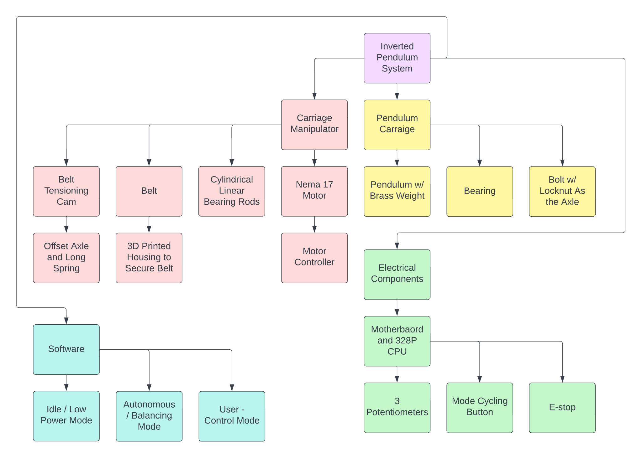

Figure 6.1.1

## 

## Flow Chart of Operations

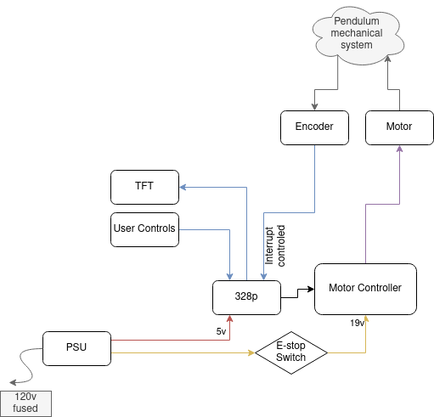

Figure 6.2.1

## Software Flow Chart

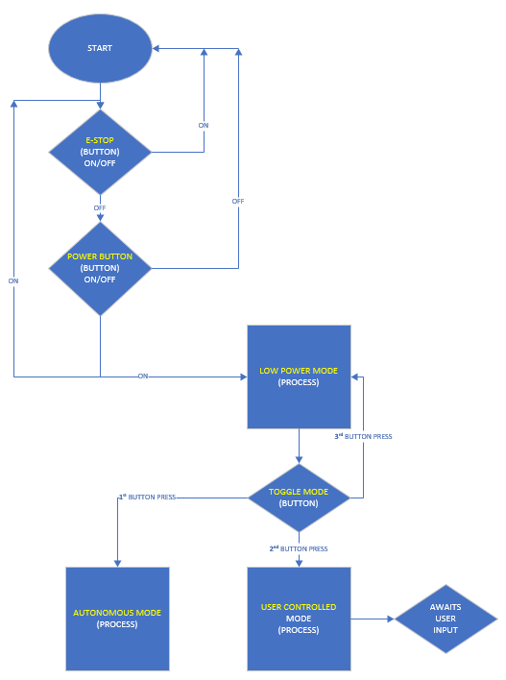

Figure 6.3.1

## Health and Safety Design Features:

* Protective shielding around the pendulum’s range of motion to avoid pinch points and physical contact.
* Capacitive e-stop and manual e-stop in case of emergency.
* All electrical components are grounded to prevent dangerous discharge.
* All components shall be ventilated and fan cooled to regulate temperatures.
* Access to embedded components shall be easy to clean the machine and remove dust and debris.

## Used Engineering Standards:

* EC TR 61923: IEC standards for instruments in household/indoor environments
* IEC 60745: IEC standard for power tools and similar motor controlled appliances
* IEC 60364-1: Rules for general design (fuses, proper grounding, insulation)

# Task Plan

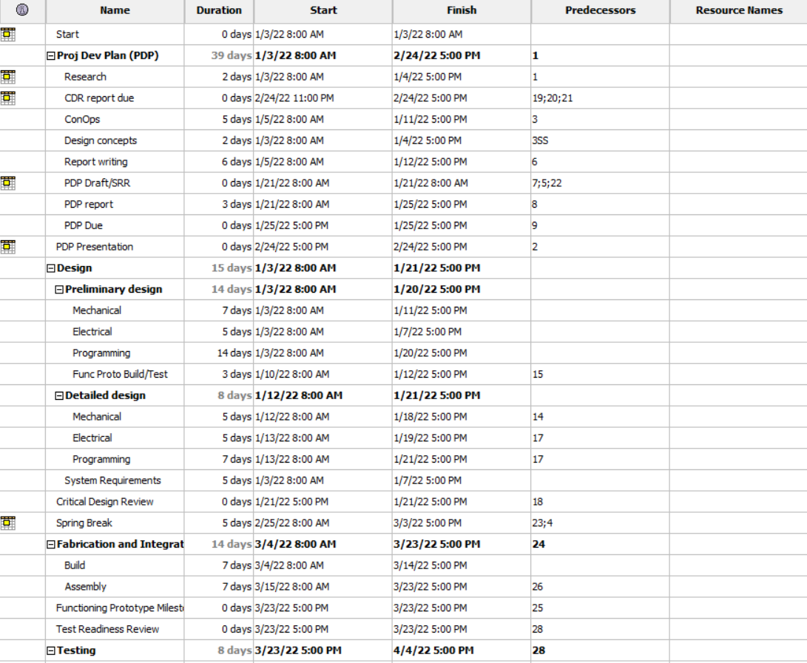

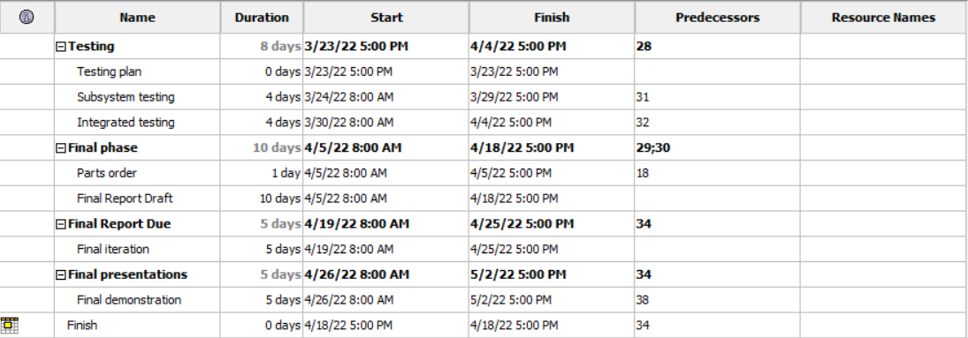

Figure 7.1.1

# Budget/BOM

[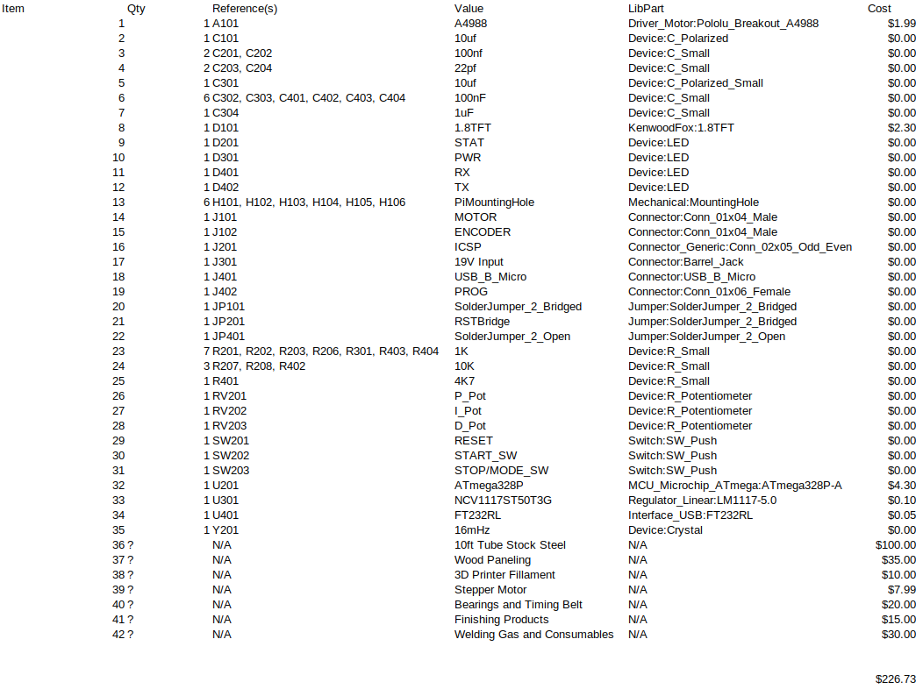](https://github.com/KenwoodFox/EG-310-InvertedPendulum/blob/feat/PDP_draft_%231/Media/Notes/Pendulum328BOM.csv)

Figure 8.1.1

# References

Figure (1.2.1) (n.d.). *Rotary Inverted Pendulum*. Quanser. Retrieved January 22, 2023, from

https://www.quanser.com/wp-content/uploads/2017/03/ROTPEN-graphics.jpg

Figure (1.2.2) (n.d.). *Lego, Raspberry and Python Project - Reaction Wheel Inverted Pendulum*.

(2022, April 16). YouTube. Retrieved January 22, 2023, from https://youtu.be/WObG2LoSEwQ

# Appendixes:

## Appendix A: Calculations / Model

# 

Figure 9.1.1

## 

## Appendix B: LibreOffice Schedule

